
Report

Date | 21 September 2026
Team ID | MCA
Project Name | Strategic Employee Attrition Intelligence Dashboard
Maximum Marks | 5 Marks

The Strategic Employee Attrition Intelligence Dashboard is developed using Power BI to analyze employee performance, career growth, retention, and attrition patterns. The dashboard provides interactive visualizations and key performance indicators to understand factors such as overtime, performance ratings, salary growth, work-life balance, employee engagement, work model, and career level. The analysis helps identify important workforce patterns that can support data-driven employee acquisition and workforce planning decisions.

Report 1: Employee Performance Career Growth Intelligence

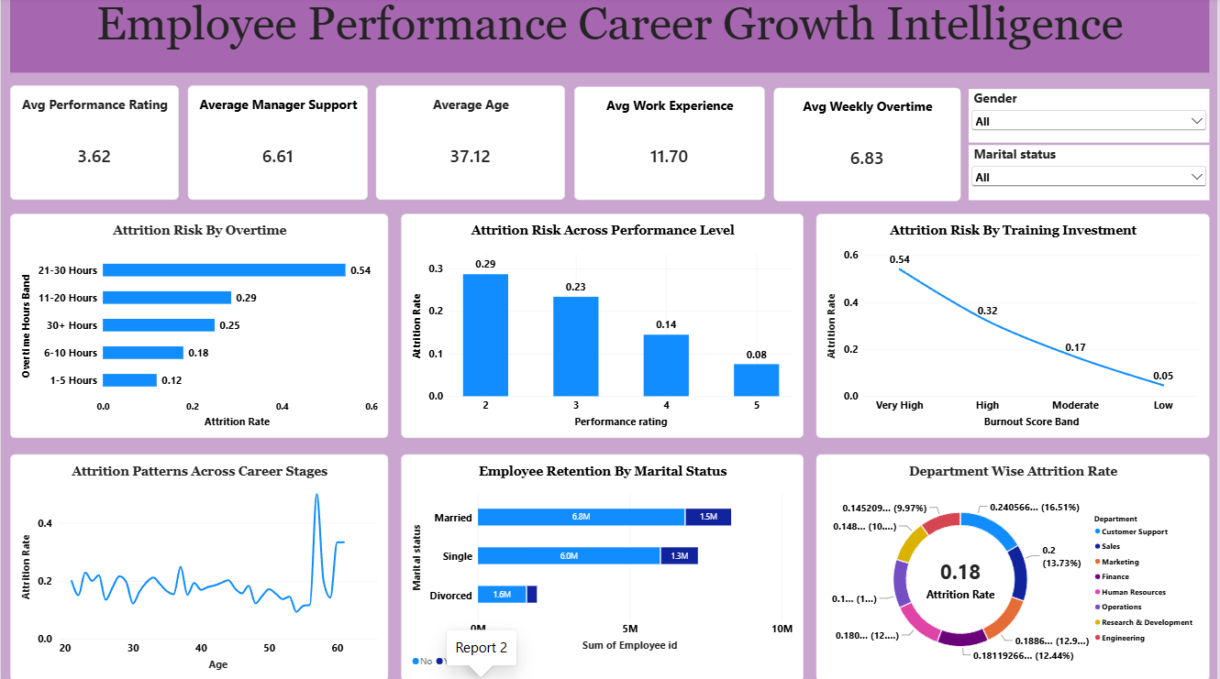

Observations:
- Employee Performance: The average performance rating is 3.62, indicating that employees generally show a moderate level of performance.

- Manager Support: The average manager support score is 6.61, showing that employees receive a reasonable level of support from their managers.

- Work Experience and Overtime: Employees have an average work experience of 11.70 years and work approximately 6.83 overtime hours per week.

- Attrition Risk by Overtime: Employees working 21–30 overtime hours have the highest attrition rate of 0.54, while employees working 1–5 hours have the lowest rate of 0.12.

- Performance and Attrition: Attrition is highest among employees with a performance rating of 2 (0.29) and lowest among employees with a rating of 5 (0.08).

- Career Stage: The dashboard shows variations in attrition across different age and career stages, indicating that employee retention patterns change as employees progress through their careers.

- Department Comparison: Attrition rates vary across departments, allowing HR to identify departments that require closer examination for employee retention.
Overall Observation
The report indicates that overtime, performance level, career stage, and department are associated with differences in employee attrition. These observations can help HR understand employee retention patterns and identify areas requiring further analysis.

Report 2: Employee Retention Performance Intelligence
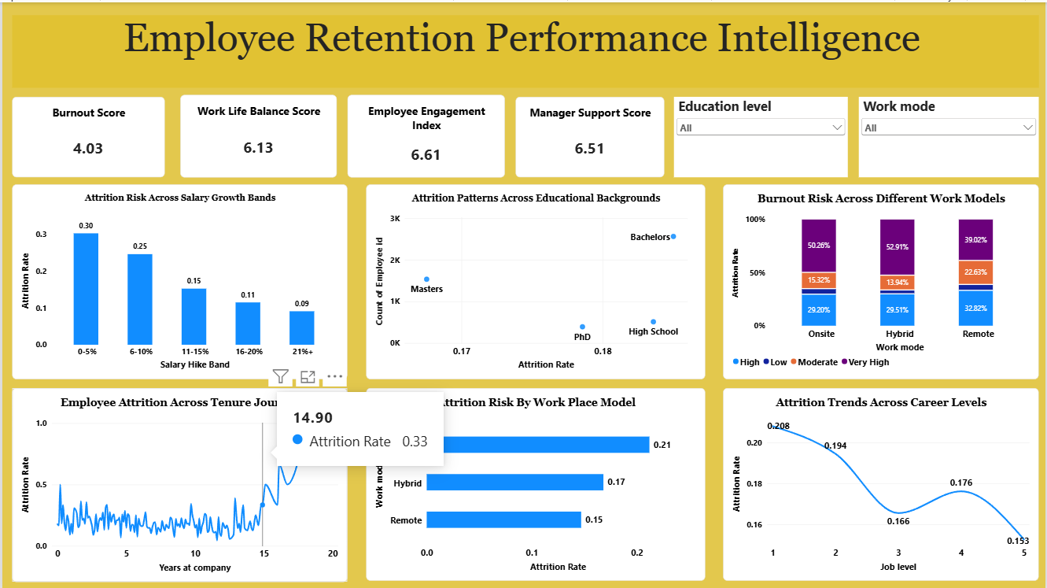

Observations
- Burnout and Work-Life Balance: The average burnout score is 4.03, while the average work-life balance score is 6.13.

- Employee Engagement: The employee engagement index is 6.61, indicating the overall engagement level represented in the dataset.

- Manager Support: The average manager support score is 6.51, providing an indication of the level of managerial support experienced by employees.

- Salary Growth and Attrition: Employees in the 0–5% salary hike band have the highest attrition rate of 0.30, while employees receiving a 21%+ salary hike have the lowest rate of 0.09.

- Workplace Model: Attrition varies by work model. The dashboard shows an attrition rate of approximately 0.21 for onsite, 0.17 for hybrid, and 0.15 for remote employees.

- Career Level: Attrition varies across job levels. The displayed values are approximately 0.208 at Level 1, 0.194 at Level 2, 0.166 at Level 3, 0.176 at Level 4, and 0.153 at Level 5.

- Educational Background: The dashboard compares attrition patterns across educational backgrounds such as High School, Bachelors, Masters, and PhD, allowing differences between education groups to be examined.
Overall Observation
The report highlights differences in employee attrition based on salary growth, work model, career level, educational background, burnout, work-life balance, and employee engagement. These factors provide HR with useful information for understanding retention patterns and supporting employee-retention analysis.

